Creating a private blockchain on Ec2 remote server

Contents

Code 2

GitHub Repo 2

Docker Implementation 2

Implementation 3

Creating an EC2 instance 3

Creating a Security Group 5

Installing Ethereum on EC2 instance 6

Setup directory to create Private Network 8

Create Accounts 9

Copy Bash files to server 9

Create Bootnode 10

Setup genesis block 10

Initialize node 12

Start Bootnode using bash file 12

Start Node1 using Bash file 13

Start Node2 using bash file 14

Start Node3 using bash file 14

Checking Peers of node1 15

Peers count on node2 and node3 15

Validation of Blockchain 15

Curl Operation on localhost 15

Curl Operation from local System 15

Connection to local environment 16

Download keystore 16

Connecting Remote Blockchain to Metamask 17

Importing accounts into Metamask using Keystore files 17

Contracts 18

Solution Architecture 19

Process Flow 19

Flight Contracts 20

Running Status 20

Booking Status 20

Airline Contracts 20

Transaction Contracts 20

# Code

We have created a repository on github and we have checked in all code for this project there. Bash files used for running blockchain node are also checked in under directory **bashfile**. Details of commands used for creating this blockchain network is recorded in **readme.md** file.

## GitHub Repo

[VarunKesarwani/PrivateBlockChain: Setting private block chain network (github.com)](https://github.com/VarunKesarwani/PrivateBlockChain)

## Docker Implementation

We have also implemented a blockchain creation process using docker. This implementation was done for local machine, which would help in development and testing of contracts on local machine before deploying these contracts to remote server.

We have implemented a single node implementation of blockchain using docker-compose.yml present in github repository. As per this implementation we have a mining block and a main node connected to boot node. This main node exposes an RPC port to connect local environment like Metamask and Remix.

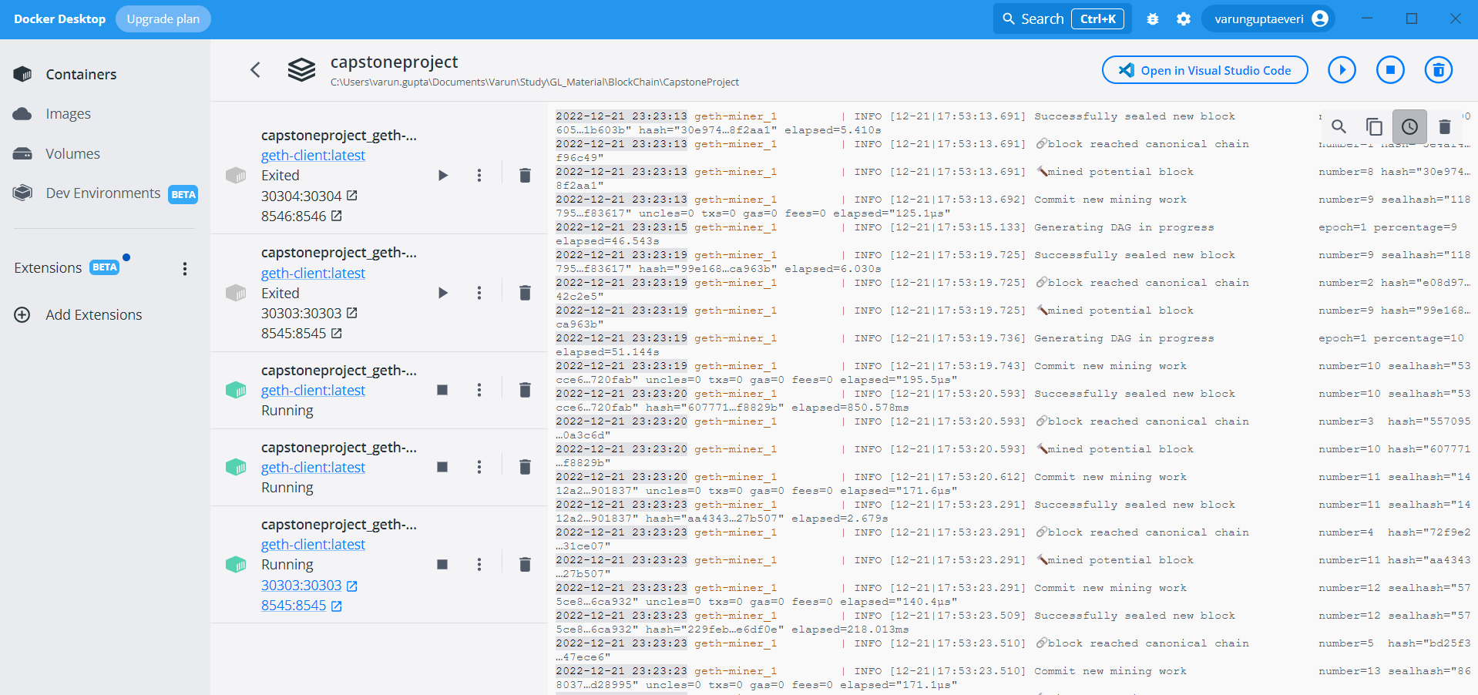

# Architecture

# Implementation

## Creating an EC2 instance

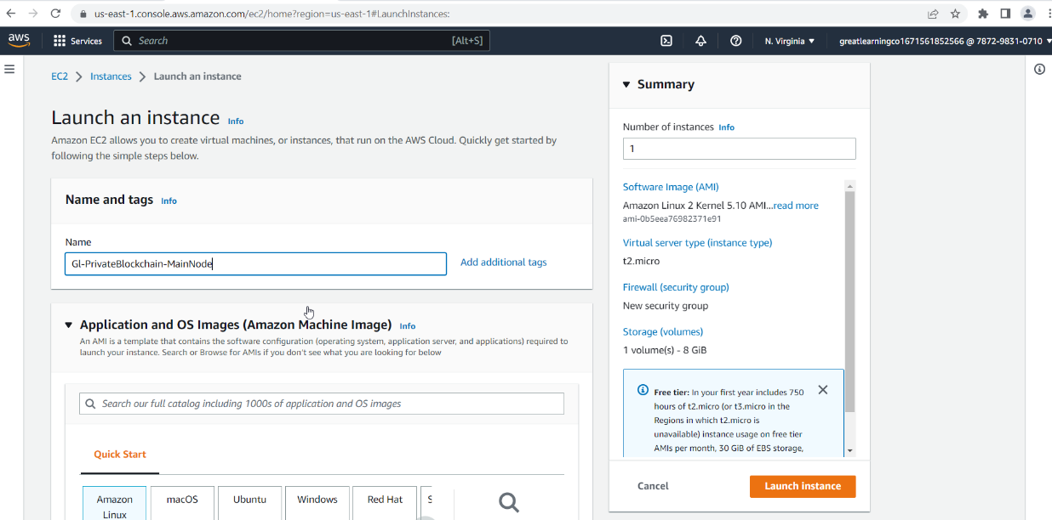

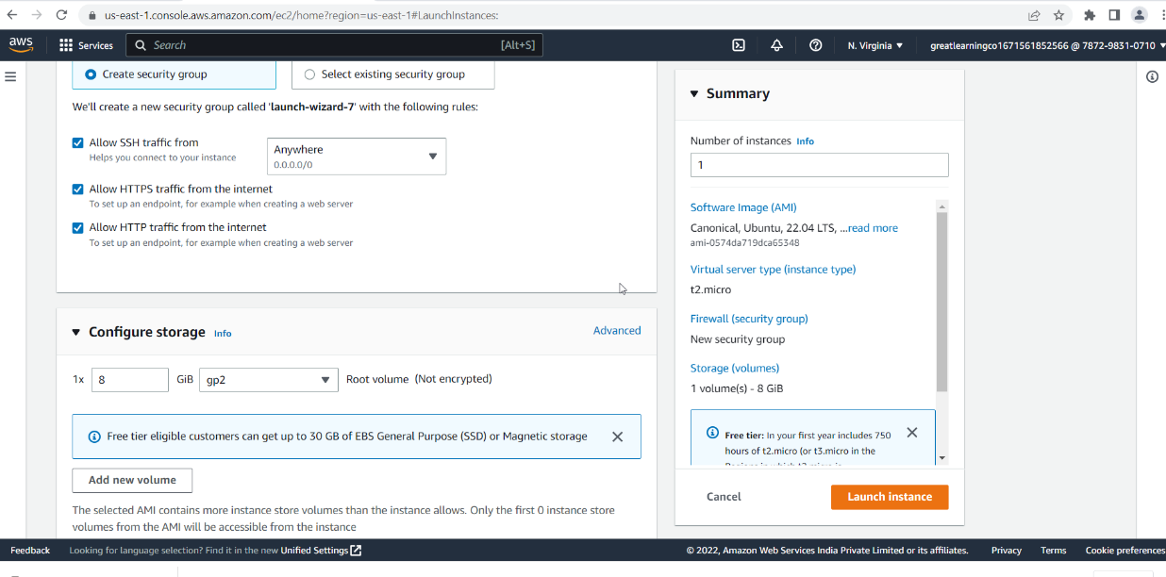

## Creating a Security Group

A new security group was created which provided external access to ports 8545, 8546 and 8547. These ports would be mapped to individual nodes.

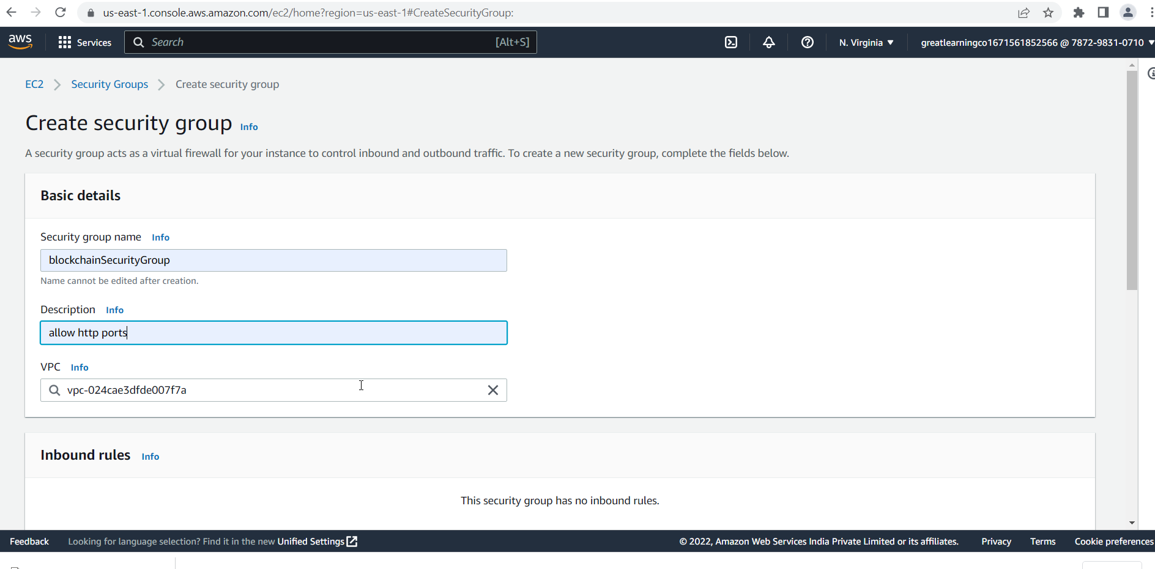

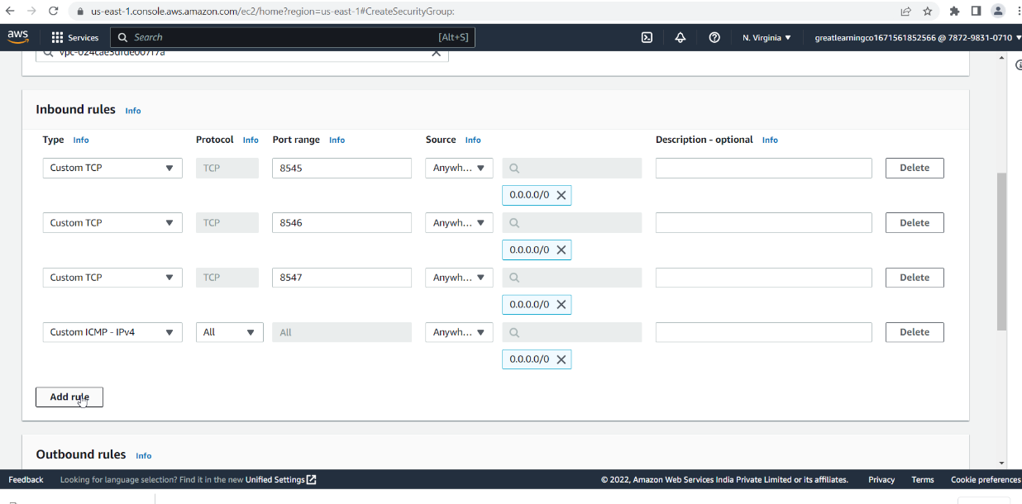

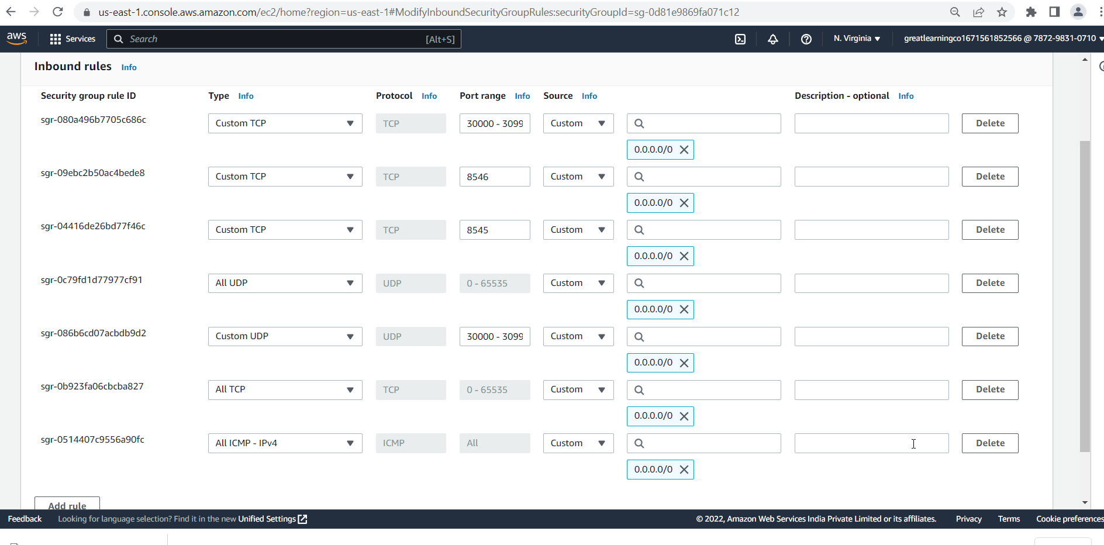

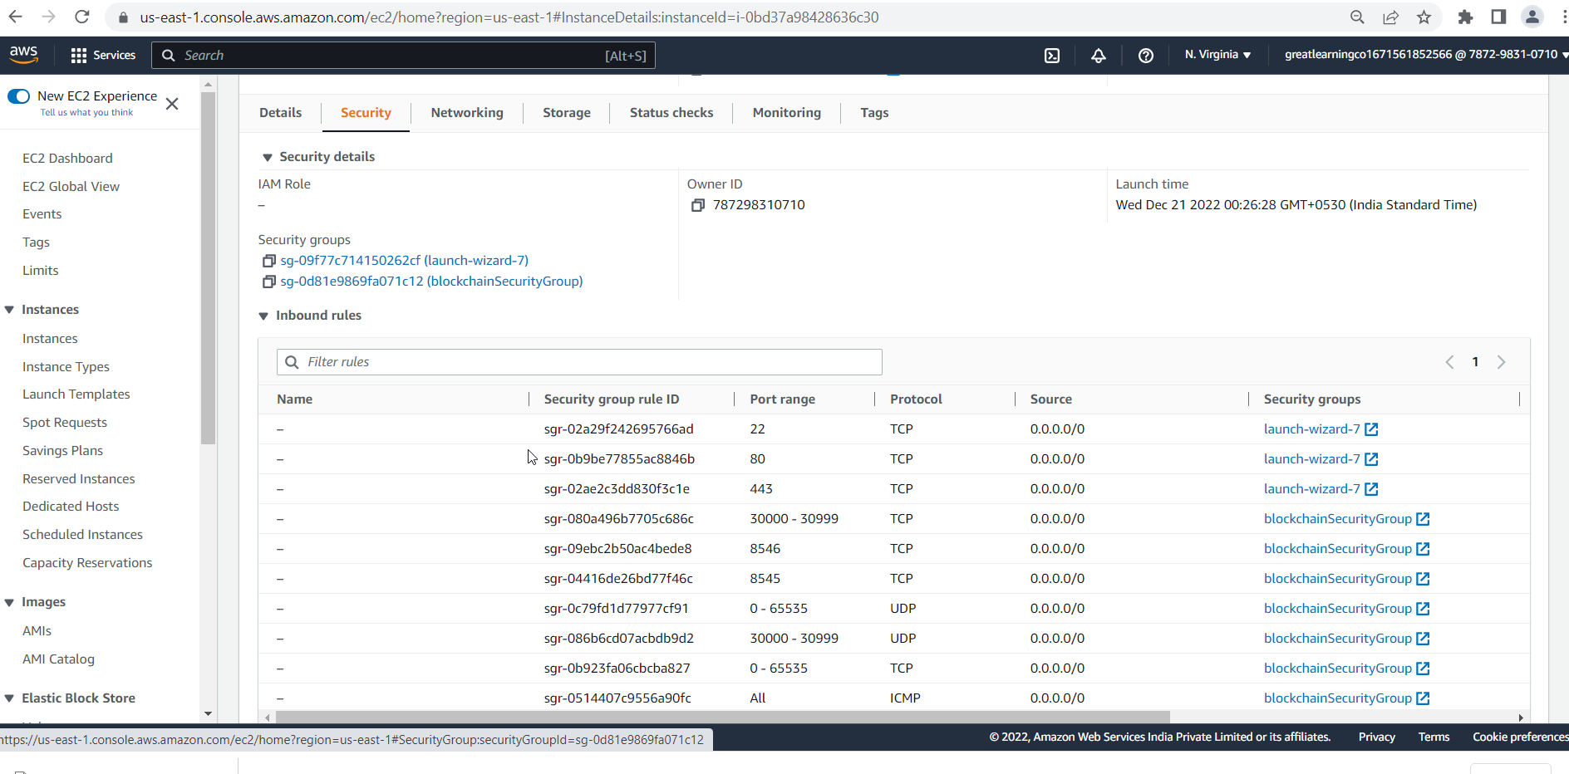

## Installing Ethereum on EC2 instance

After connecting to EC2 instance, we used below mentioned command for installing Ethereum.

* *sudo add-apt-repository -y ppa:ethereum/ethereum*
* *sudo apt-get update*
* *sudo apt-get install Ethereum*

We also installed Netstat tool to validate opening of ports, when Ethereum network is running

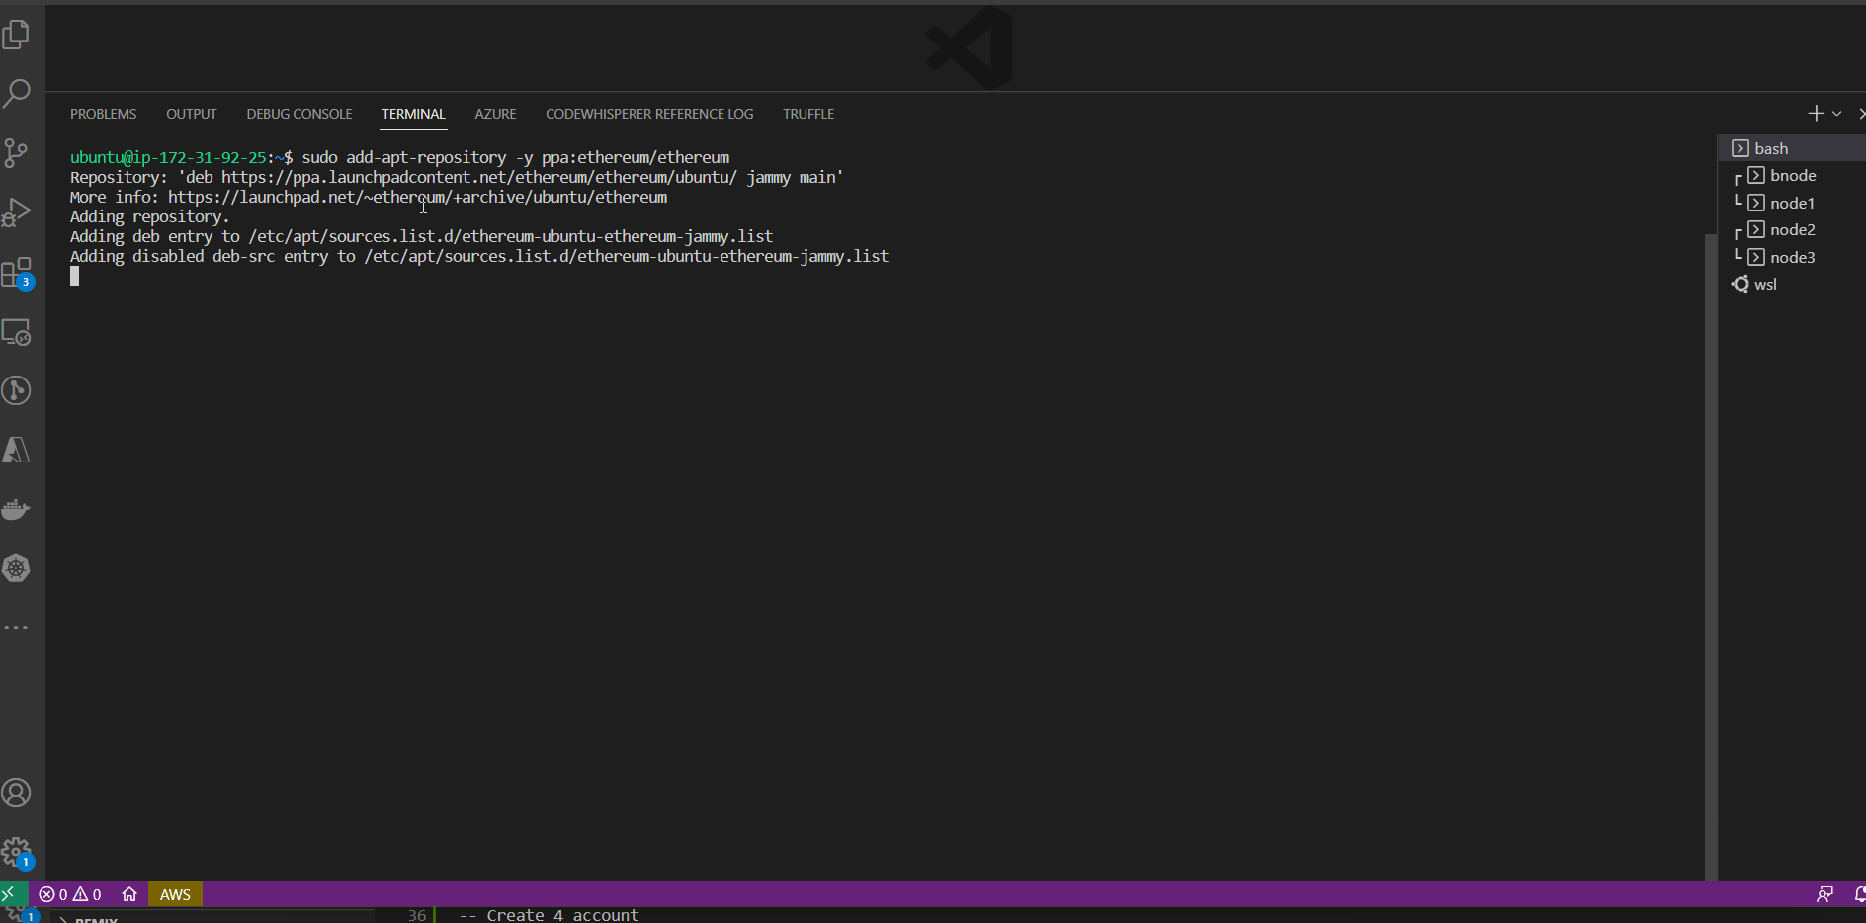

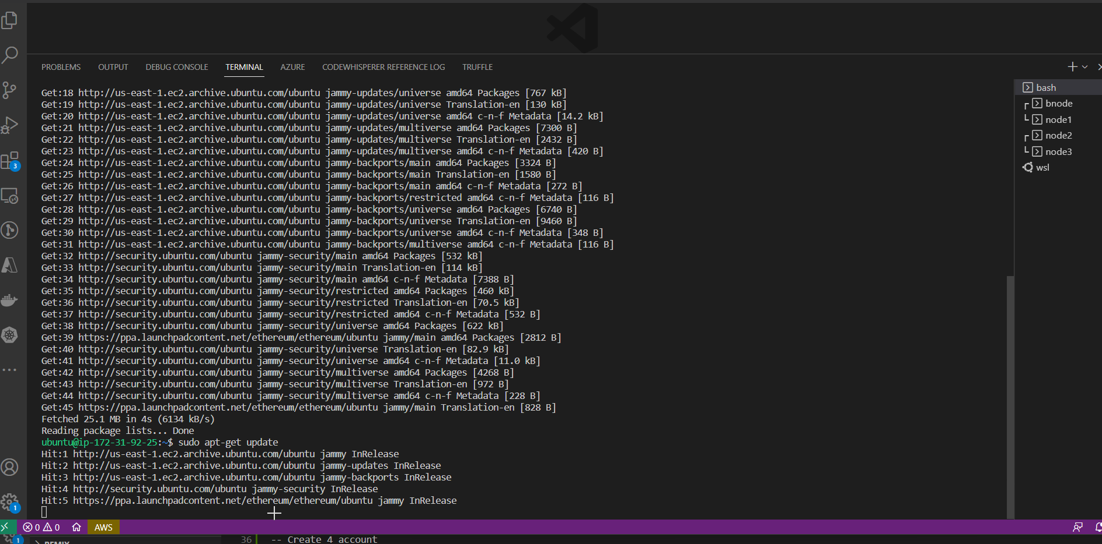

## Setup directory to create Private Network

In order to Setup 3 nodes network and a boot node, we have created the following directories.

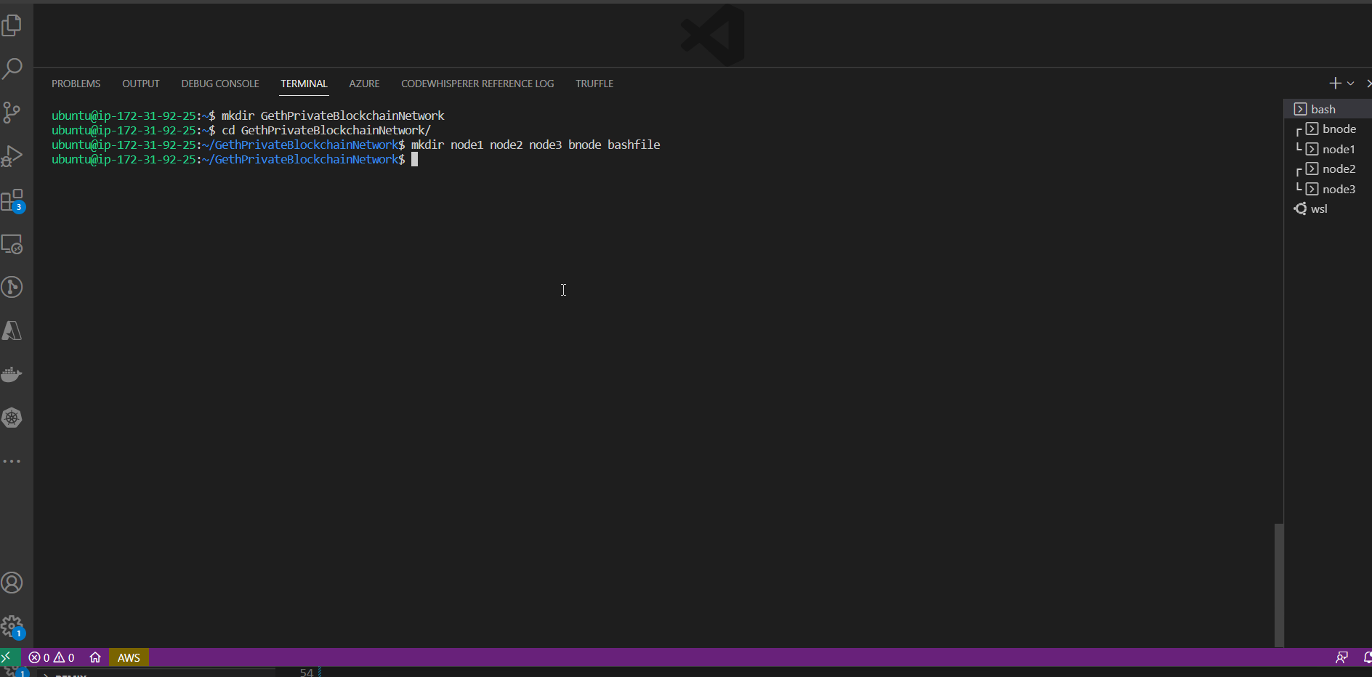

We have also created two files, named accounts.txt and password.txt, to hold account related data.

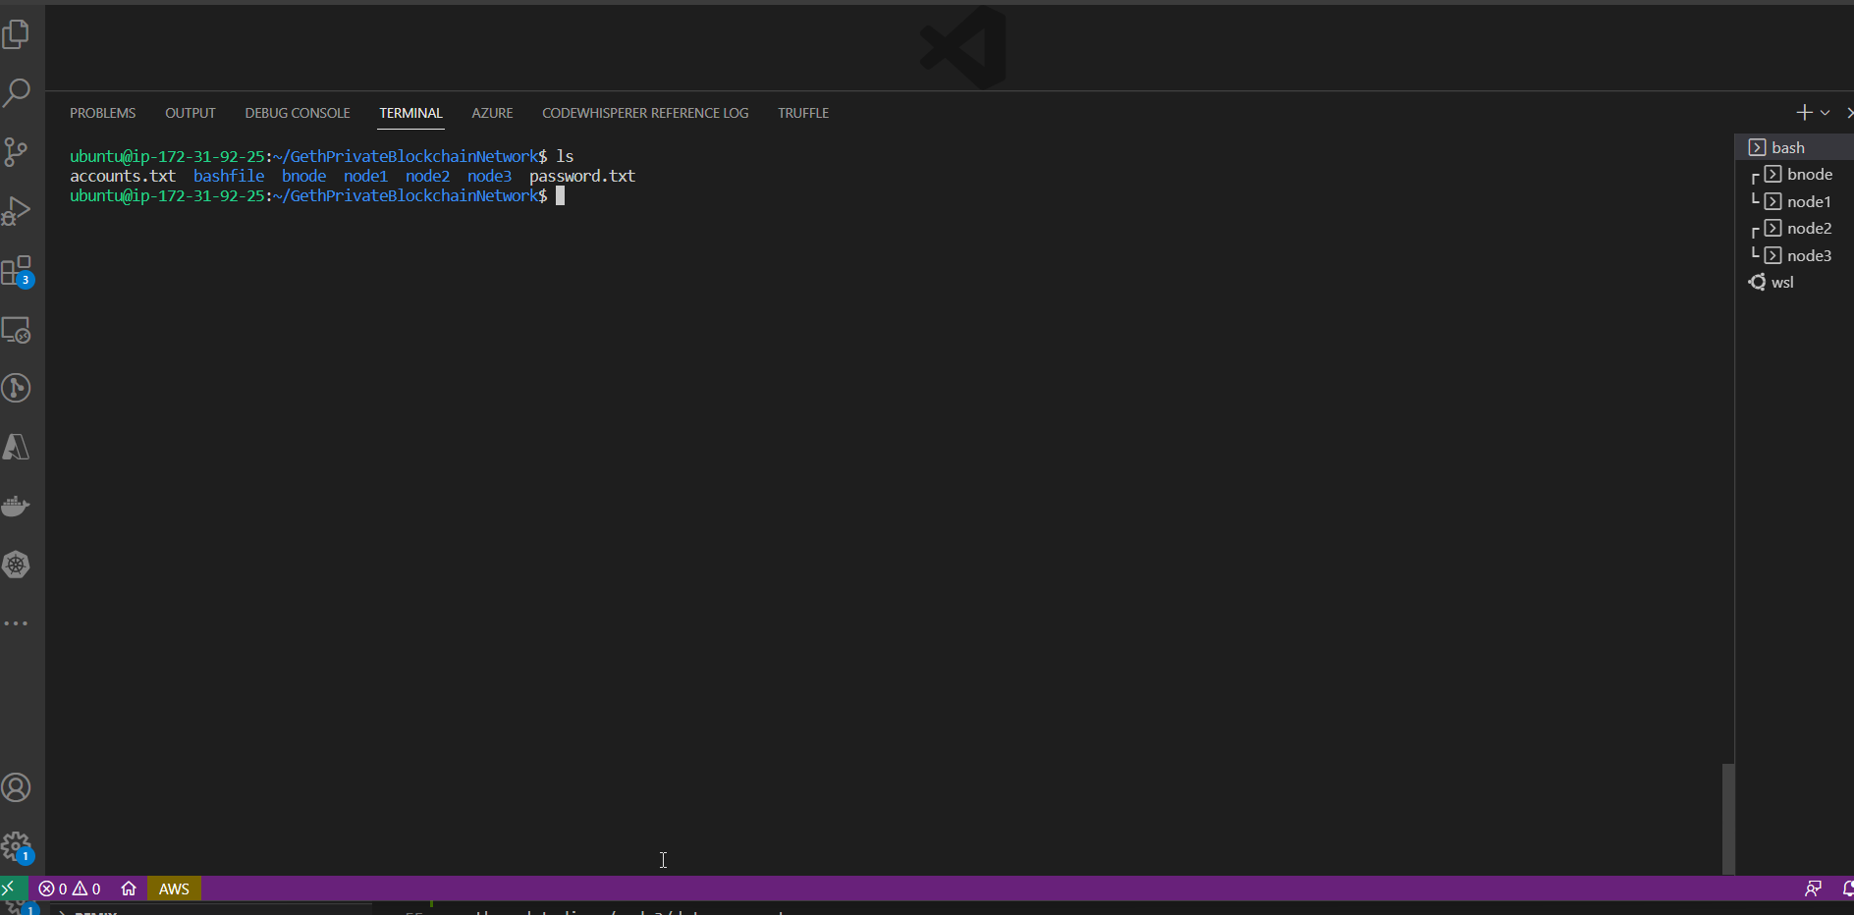

## Create Accounts

We created multiple accounts on all 3 nodes, 4 accounts for node1, 2 accounts for node2 and 2 accounts for node3.

We stored these accounts details on accounts.txt file for future reference.

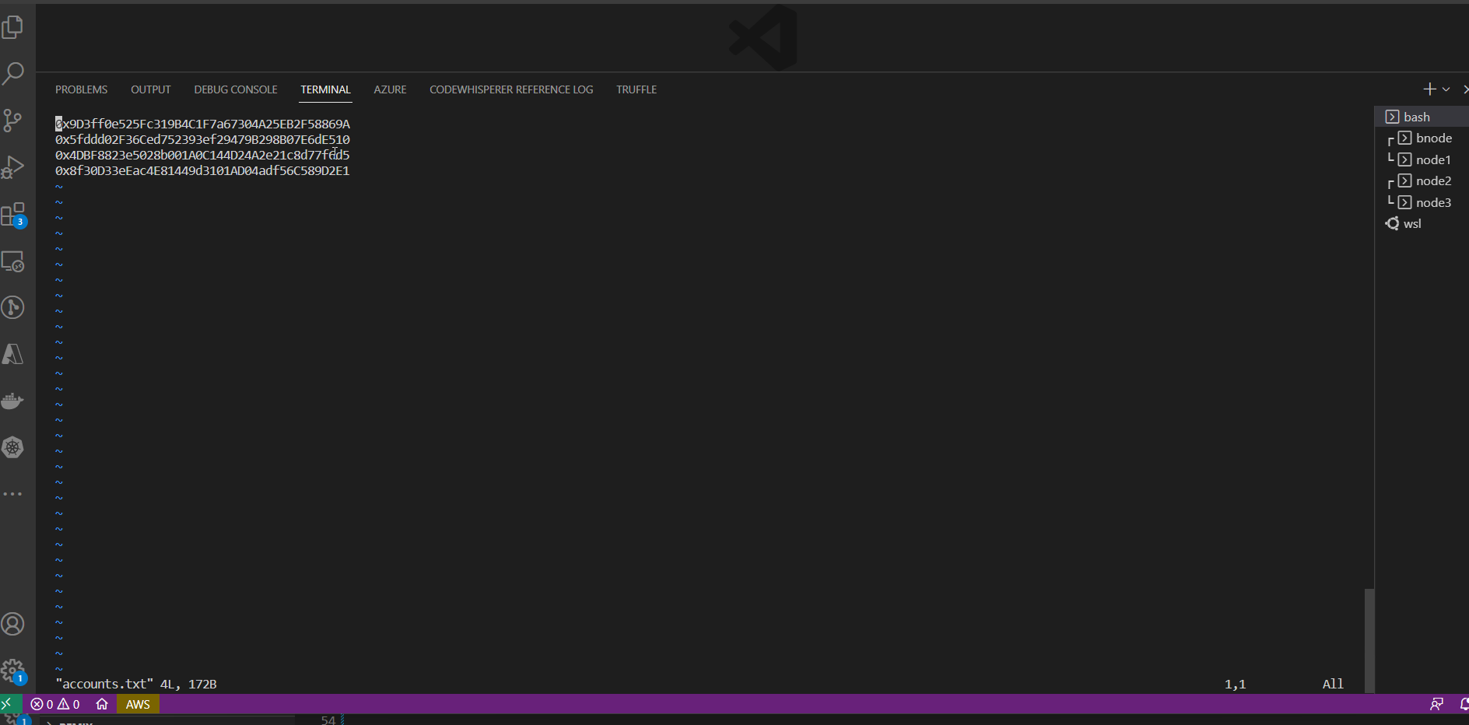

## Copy Bash files to server

We have created individual bash files for running the nodes and boot nodes. The node bash files accept 3 parameters, which are bootnode, private ip and unlock account. Similarly we have created a bash file to start boot node and this file excepts private ip address

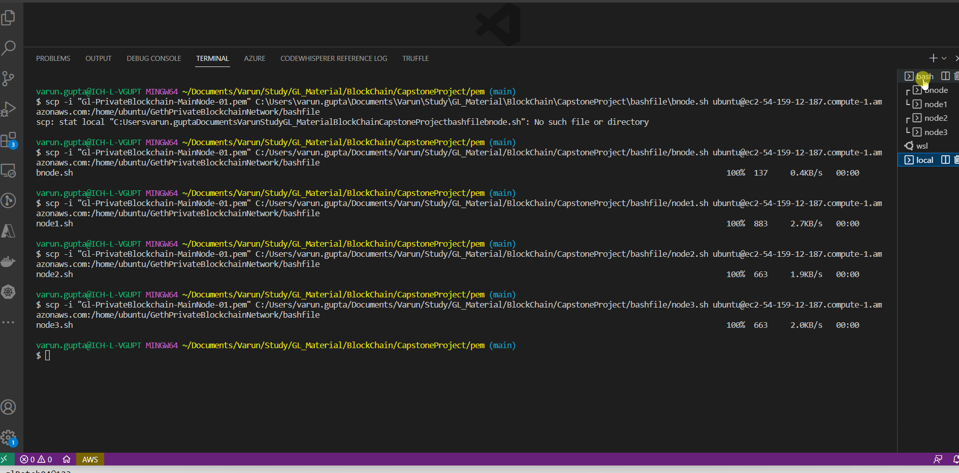

## Create Bootnode

## Setup genesis block

We setup genesis block with Chain ID as 15353, Sealer account is node1’s account 1.

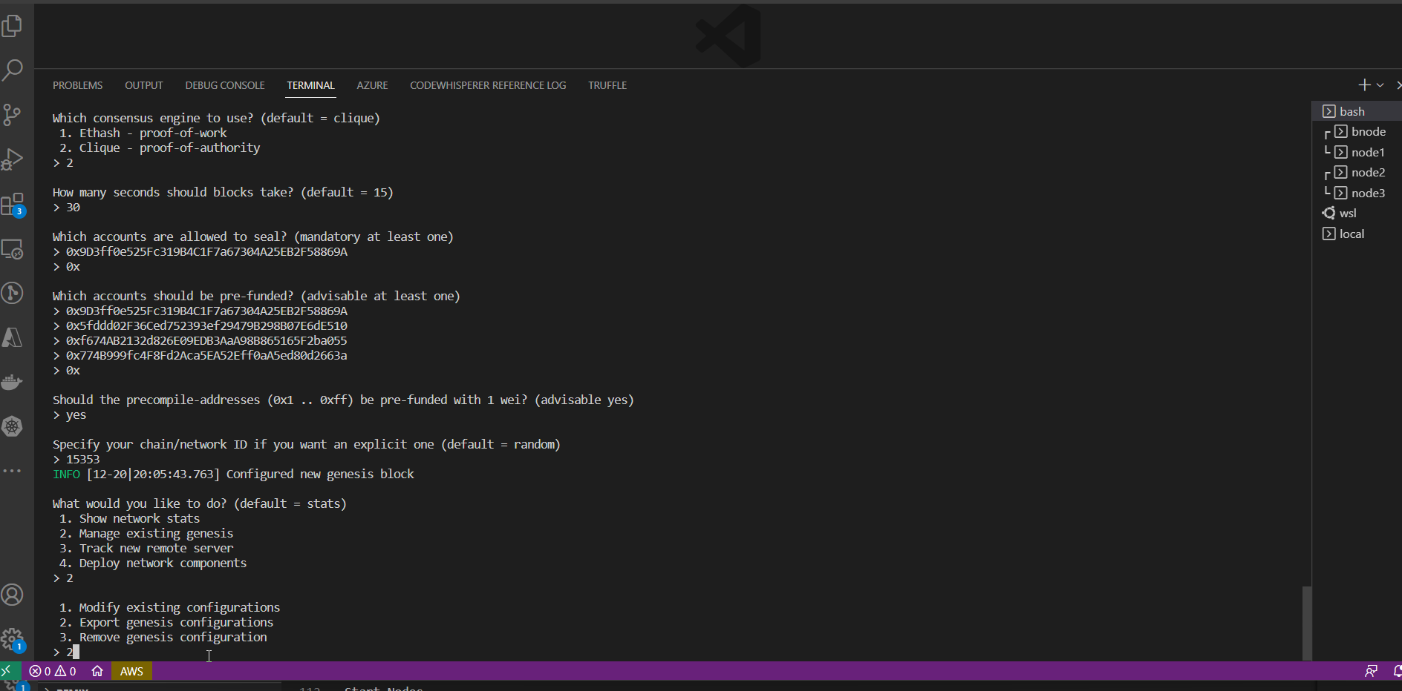

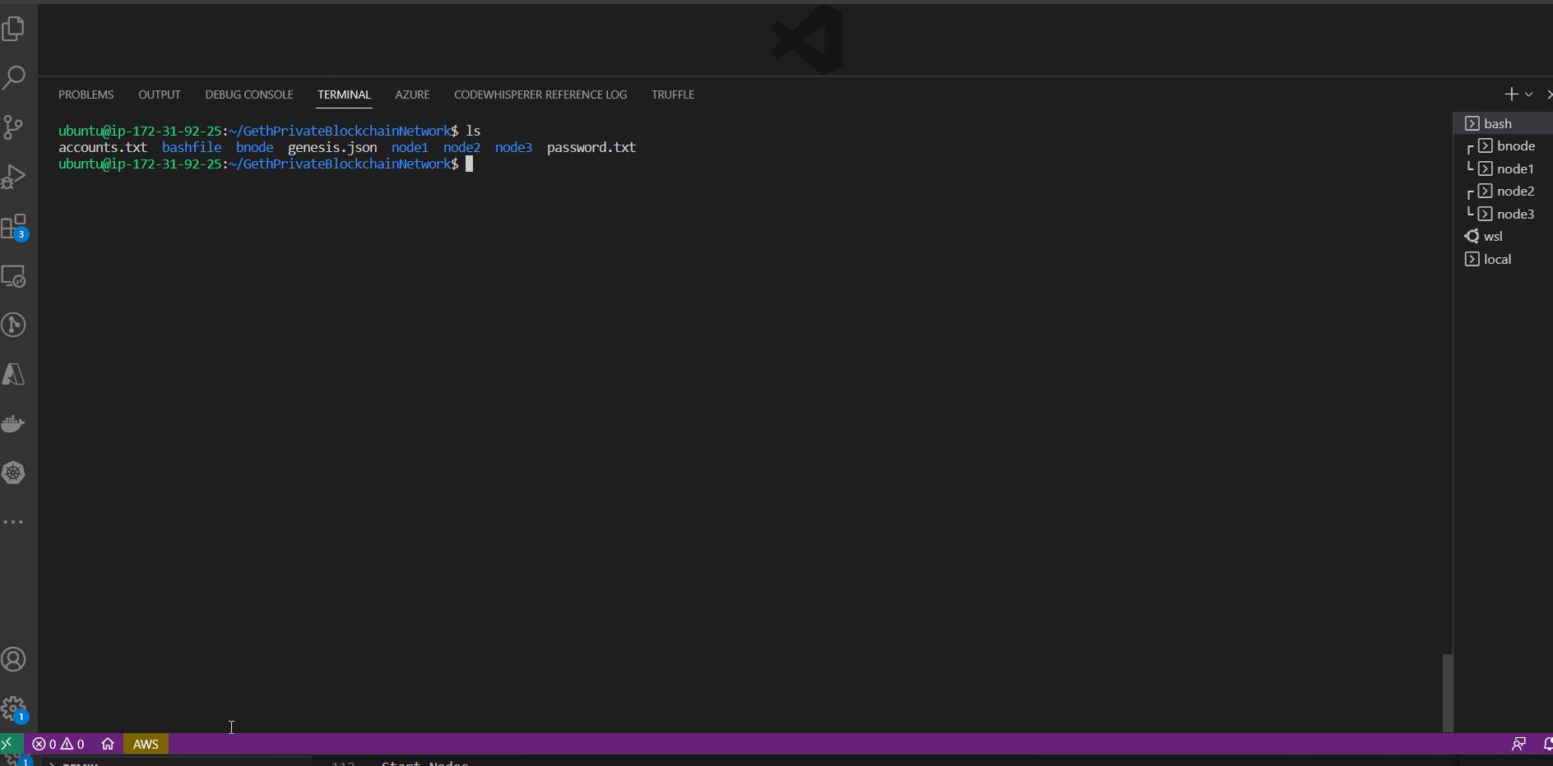

## Initialize node

## Start Bootnode using bash file

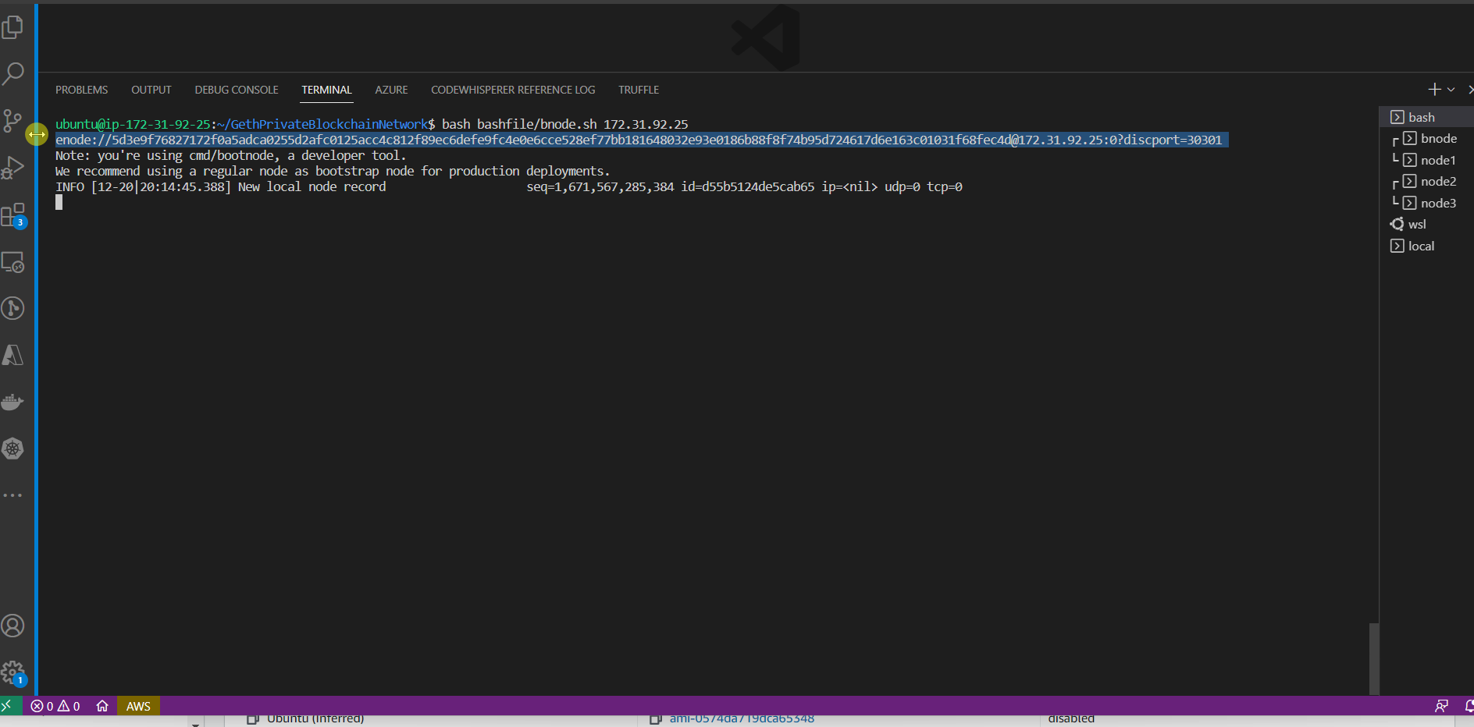

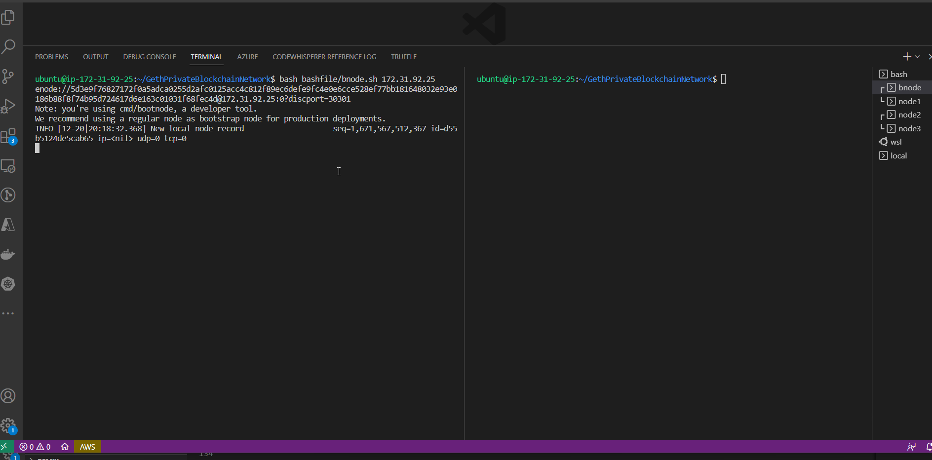

## Start Node1 using Bash file

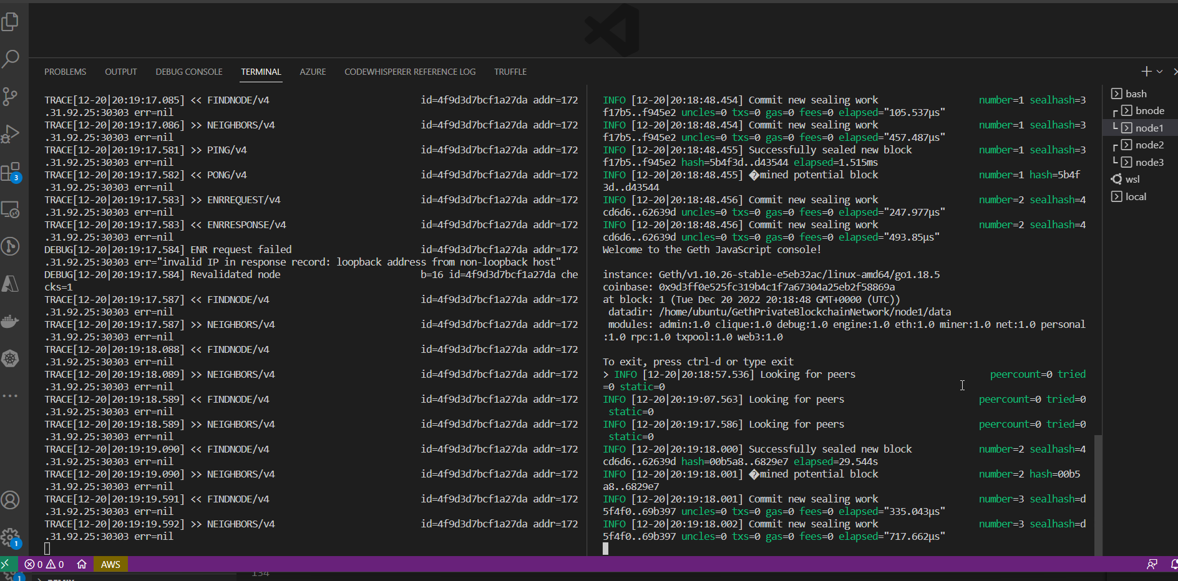

## Start Node2 using bash file

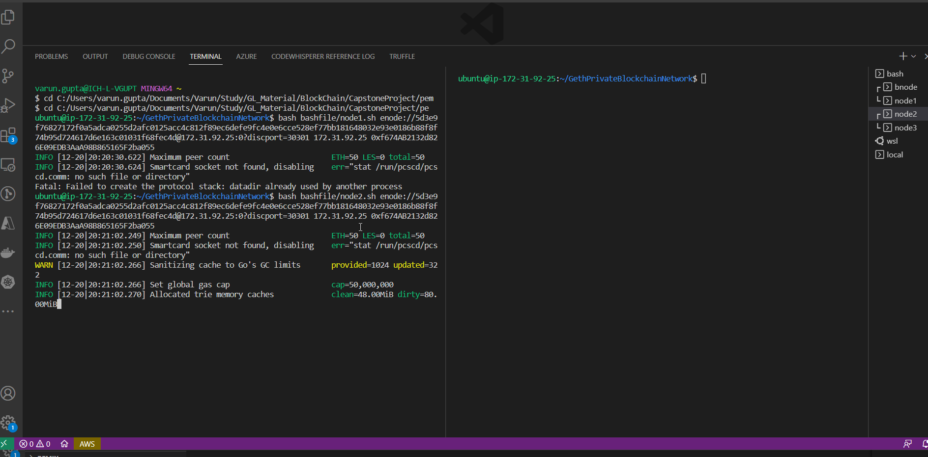

## Start Node3 using bash file

## Checking Peers of node1

## Peers count on node2 and node3

# Validation of Blockchain

## Curl Operation on localhost

This exhibits the RPC connectivity with blockchain



## Curl Operation from local System

This exhibits the ability to connect to blockchain hosted remote networks.



Fetching account details for node1 and node2



Creating a New Account from local system



Transferring funds from older account to newly created account

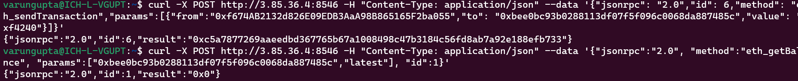

Transaction results



# Connection to local environment

## Download keystore

We download the keystore files for each account, so that we could upload the same into Metamask

## Connecting Remote Blockchain to Metamask

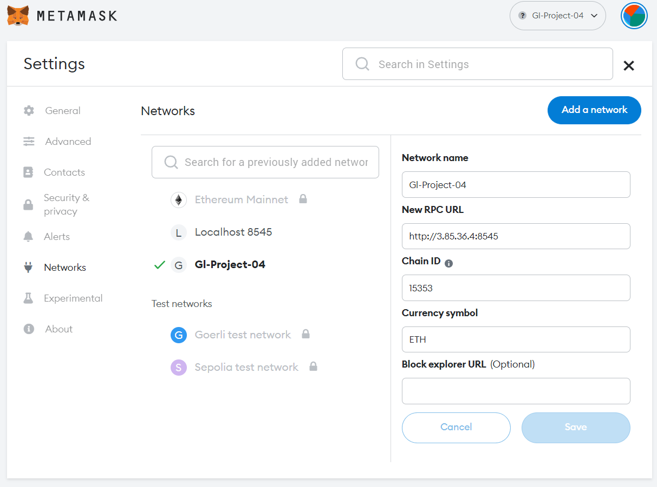

## Importing accounts into Metamask using Keystore files

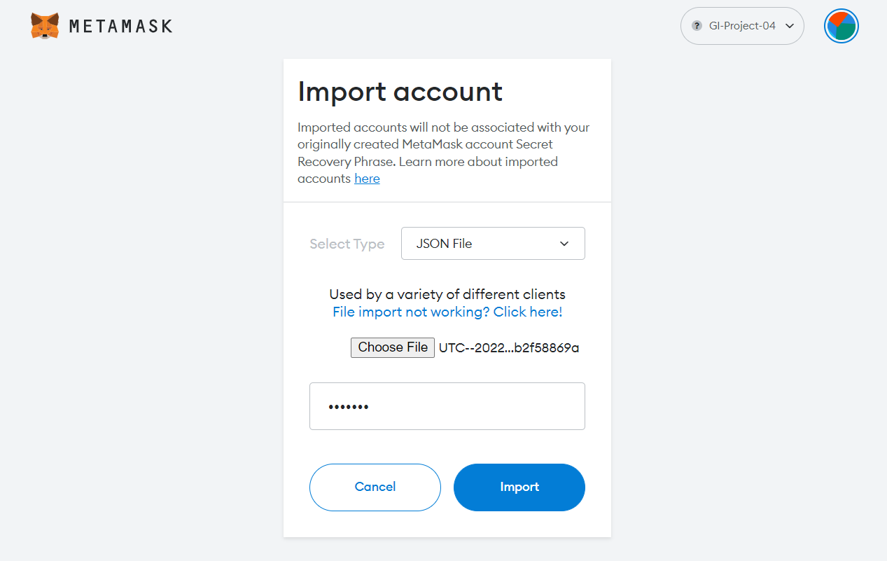

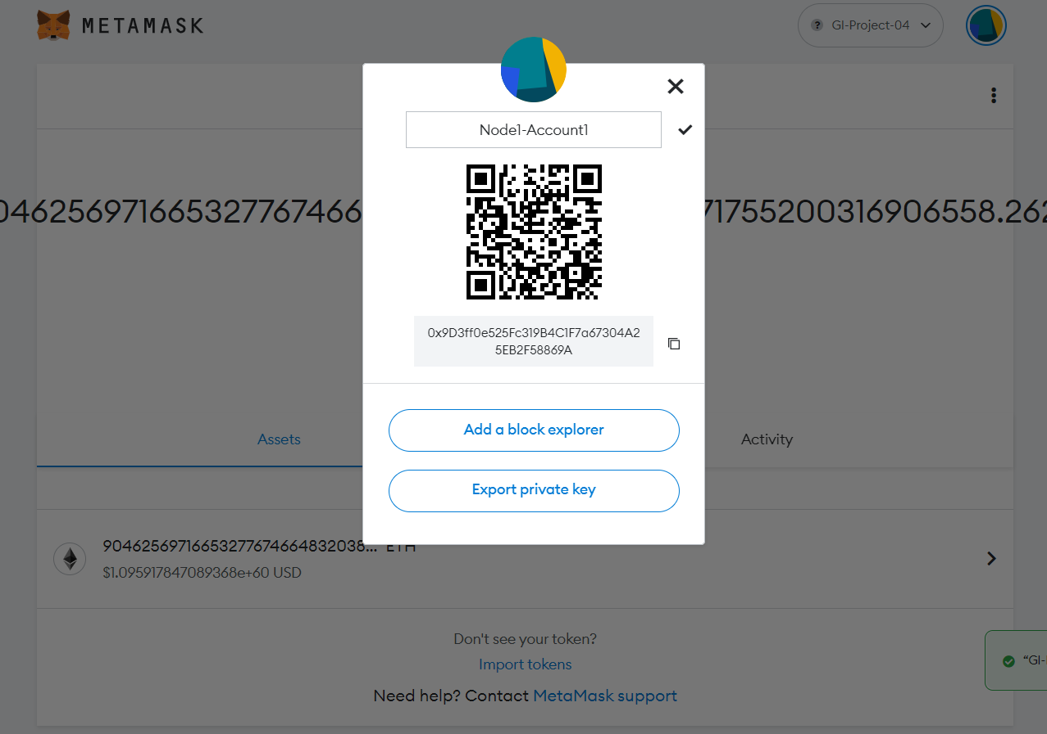

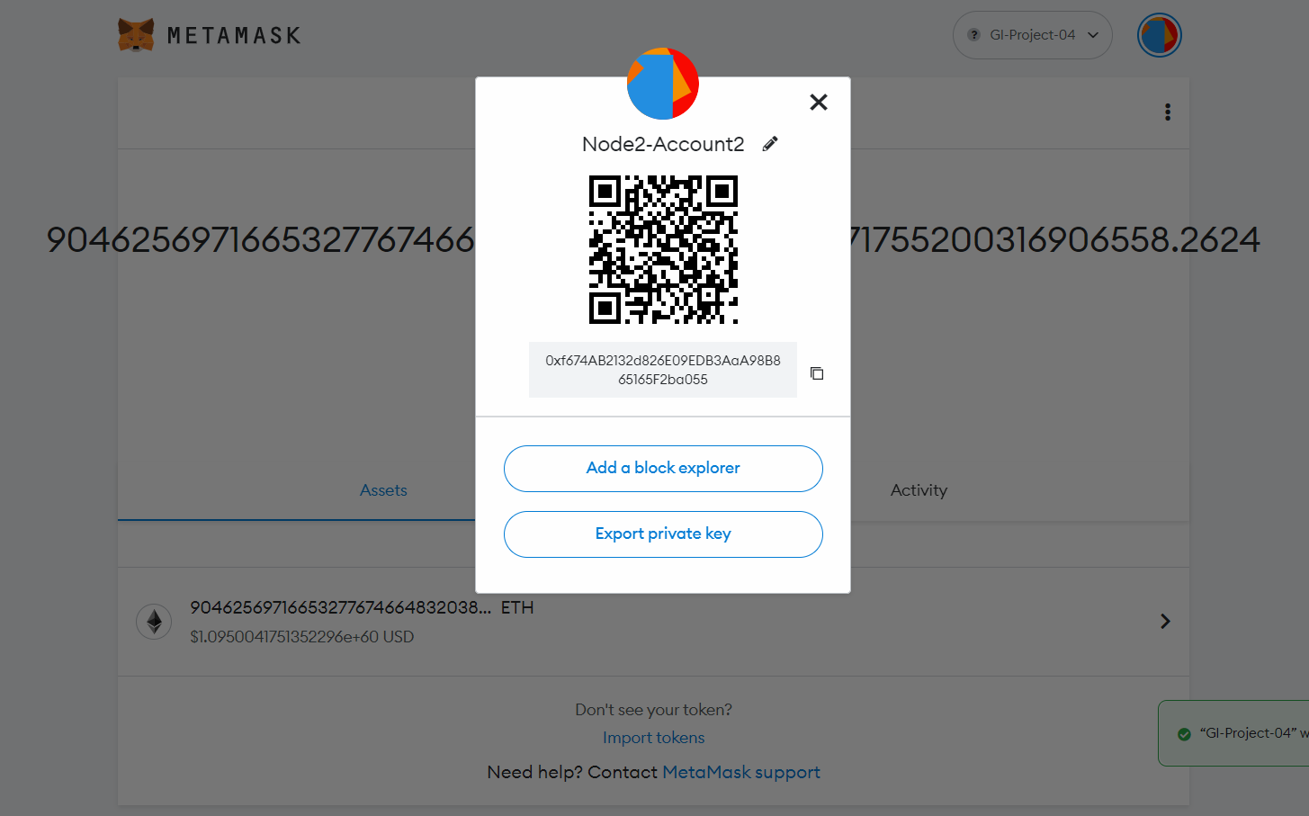

# Contracts

In order to resolve this issue, we have developed 3 contracts

1. FlightContract: This contract performs all operations related to one specific flight.
2. AirlineContract: This contract performs airline specific operation and creates instance of FlightContract and hold flights in mapping.
3. TransactionContract: This contract is for performing booking site related operation.

## Solution Architecture

## Process Flow

## Flight Contracts

All operations pertaining to flight operation are handled by this contract. This maintains flight running and booking status. It also maintains guest list, price, availability and booked seat details.

### Running Status

**SCHEDULED**: At this phase the flight is only created and doesn’t allow booking. Flight details like Price, Number of seats are initialized at this stage

**DEPARTED**: At this stage flight is departed, and users are not allowed to perform any booking or cancellation operation

**LANDED**: At this stage we start calculation of concluded state, a window of 24 hours is provided to resolve any dispute.

**DELAYED**: Here we input delay time in Epoch time and users are compensated based on delay time

* + 2 hours delay: refund 10%
  + 6 hours delay: refund 20%
  + 12 hours delay: refund 40%
  + 24 hours delay: refund 80%
  + Beyond 24 hours: Cancel and refund 100%

**CANCELLED**: Here full refund is provided to all booked user

**CONCLUDED**: At this stage, the final amount is calculated, and the flight is deleted.

### Booking Status

**PRESALE**: At this stage users are not allowed to book tickets

**SALE**: At this stage, users are allowed to book ticket for specific flight

**READY**: This is 24 hours before departure. At this stage price of ticket is increased by 20%

**CLOSED**: At this stage, users are not allowed to perform any booking or cancellation operation.

**FINALISED**: This is landed stage, where users are provided 24 hours to raise dispute.

**CANCELLED**: At this stage refunds are provided to users.

## Airline Contracts

This contract can be treated as interface for airline operation.

**CreateAirline**: In this we create an airline with an airline address. Multiple airlines can be created, and this is maintained in mapping

**ScheduleFlight**: Here we created a flight, initializing flight with flight number, Schedule date and schedule time. Date and time are maintained as Epoch time.

**EnableFlight:** Here we enable flight and open it for user to book ticket for a flight. Airline provided details such as price and number of seats

**FlightOperation**: There are multiple functions created for airlines to perform flight operation like ready flight, delay flight, cancel flight.

### Transaction Contracts

This contract can be treated as booking sites.

**Book**: Allows user to book ticket to enabled flight

**Cancel**: Allows user to cancel their booked ticket

**GetPrice**: Allows users to get price of specific flight

**GetAvailabilty**: Allowed users to check available seats on a flight

**GetGuestByUuid**: fetch user seat number by unique id

**GetGuestBySeatNo**: this function fetches users uuid based on user seat number.